Full Stack Development with MERN
Project Documentation — Book a Doctor
Project Title | Book a Doctor — Online Doctor Appointment Booking System
Team Members | [Add team member names and roles]
Date | 19 July 2026
Version | v1.0
Document Type | Full Stack Development (MERN) Project Documentation

Table of Contents
1. Introduction
2. Project Overview
3. Architecture
4. Setup Instructions
5. Folder Structure
6. Running the Application
7. API Documentation
8. Authentication & Security
9. User Interface
10. Testing
11. Screenshots or Demo
12. Known Issues
13. Future Enhancements
14. Appendix

1. Introduction
Project Title: Book a Doctor — an online doctor appointment booking system.
Objective: To streamline the process of finding, booking, and managing doctor appointments for patients, while giving hospital staff a unified system to manage doctors, schedules, and records.
Scope: The system covers patient-facing booking, doctor-facing schedule management, admin-facing platform administration, and downstream reporting/CRM integrations (Power BI, Tableau, Salesforce).
Team Members
Name | Role | Responsibility
[Name] | Frontend Developer | React UI, component library, state management
[Name] | Backend Developer | Express API, authentication, business logic
[Name] | Database/DevOps | MongoDB schema design, deployment, CI/CD
[Name] | AI/ML Engineer | Specialty recommendation & no-show prediction models
[Name] | QA/Analyst | UAT, reporting dashboards (Power BI/Tableau)

2. Project Overview
Purpose: Book a Doctor lets patients find and book appointments with doctors online, pay for consultations, and receive reminders — while giving doctors and hospital admins the tools to manage schedules, profiles, and records.
Target Users
- Patients — search doctors, book/reschedule/cancel appointments, pay online, receive reminders.
- Doctors — manage their schedule, view upcoming appointments, update availability.
- Hospital Admins — manage doctor and patient records, oversee platform data, view analytics.
- Operations/Support Staff — track follow-ups and complaints via the Salesforce CRM mirror.
Key Features
- Patient registration, login, and profile management
- Doctor search and filtering by specialty, availability, and rating
- AI-assisted symptom-to-specialty recommendation during booking
- Appointment booking, rescheduling, and cancellation with real-time slot locking
- Online payment for consultations
- ML-based no-show risk prediction to trigger extra reminders
- Doctor dashboard for managing appointments
- Admin dashboard for managing doctors, patients, and platform data
- Admin analytics via Power BI and Tableau; CRM records mirrored in Salesforce
- Email/SMS notifications for booking confirmations and reminders
Technology Stack
Layer | Technology
Frontend | React.js, React Router, Axios, Context API
Backend | Node.js, Express.js, JWT, bcrypt
Database | MongoDB (Atlas), Mongoose ODM
AI/ML | DistilBERT-based NLP classifier, Random Forest (scikit-learn)
Analytics/CRM | Power BI, Tableau, Salesforce
DevOps | GitHub Actions (CI/CD), Docker, Render/Vercel hosting

3. Architecture
Frontend
Built with React.js as a single-page application. Role-based views (Patient / Doctor / Admin) share a common component library; React Router handles navigation and protected routes; Axios handles API calls to the Express backend. Global auth/session state is managed via the Context API.
Backend
Node.js with Express.js exposes a REST API. Middleware handles JWT authentication, role-based authorization, request validation, and error handling. Controllers are grouped by domain (auth, doctors, appointments, payments, admin). Business logic for slot-locking during booking is implemented with MongoDB transactions to prevent double-booking.
Database
MongoDB (via Mongoose) stores five core collections: User, Doctor, Appointment, Payment, and Notification. Doctor and Appointment reference the User collection; Payment references Appointment. Indexes are set on doctorId + slot for fast availability lookups.
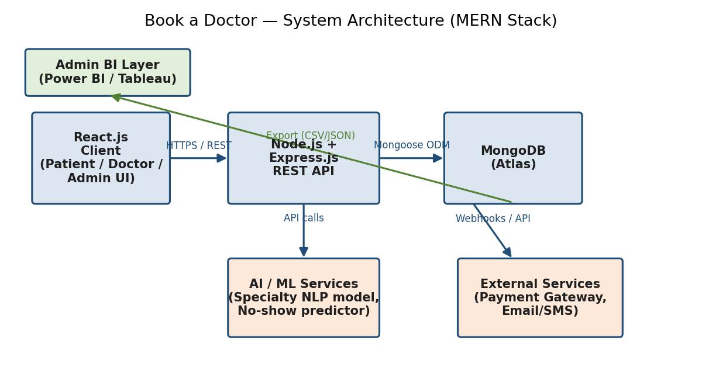
Fig. 1 — System architecture: React client, Express/Node API, MongoDB, and supporting AI/ML and external services
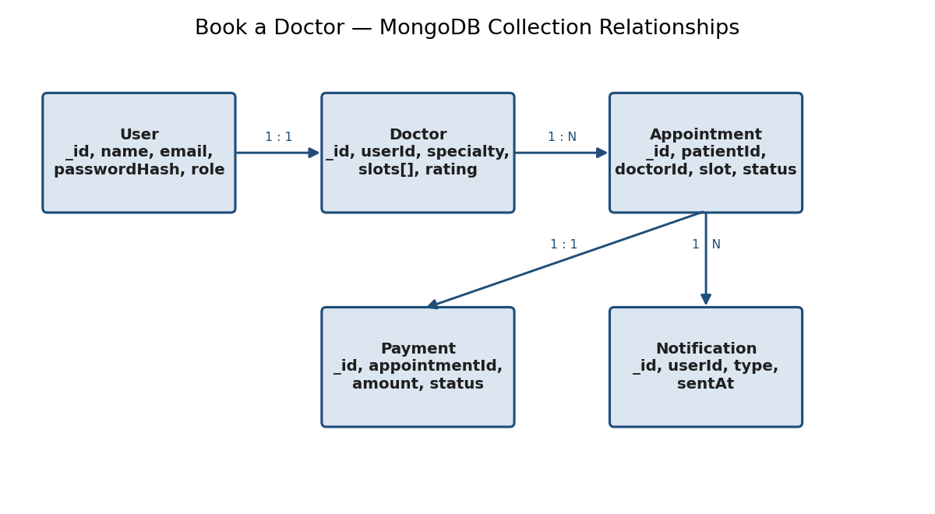
Fig. 2 — Core MongoDB collections and their relationships
Deployment Architecture
Code is version-controlled on GitHub. A CI pipeline lints, tests, and builds the app on every push; successful builds are containerized and deployed to cloud hosting, with the client served from a CDN and the API running as a managed app service against MongoDB Atlas.
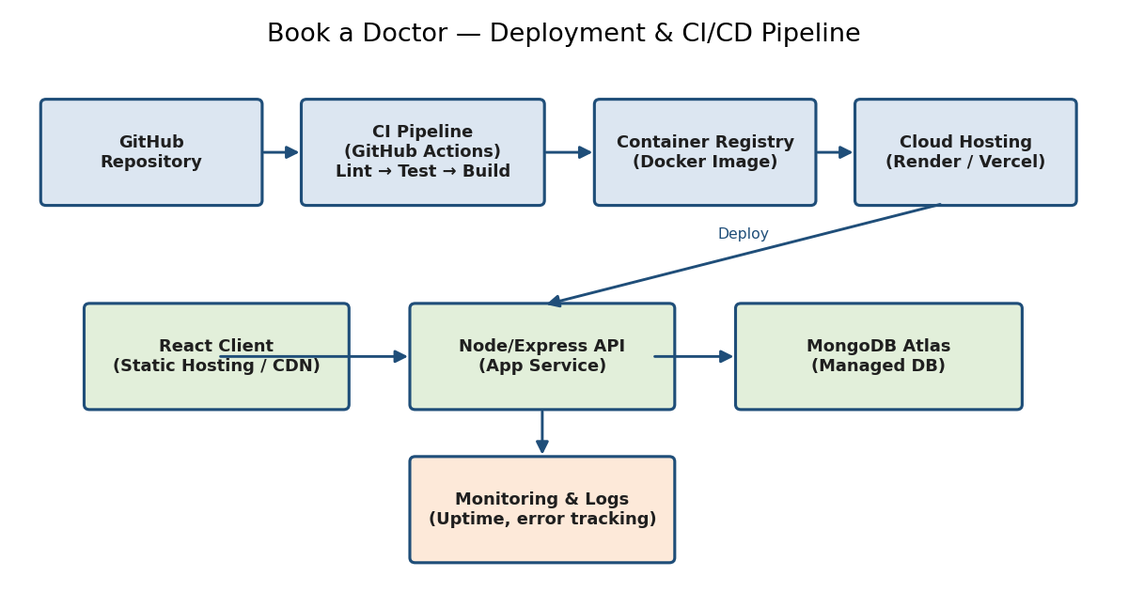
Fig. 3 — Deployment and CI/CD pipeline
Non-Functional Requirements
- Performance — API responses under 300ms for typical read operations; booking confirmation under 1s.
- Scalability — stateless API instances behind a load balancer; MongoDB indexed for high-read doctor search.
- Availability — target 99.5% uptime for the booking flow; monitored via uptime checks and error tracking.
- Security — see Section 8 (Authentication & Security) for authentication, authorization, and data-protection details.

4. Setup Instructions
Prerequisites
- Node.js (v18 or later) and npm
- MongoDB (local instance or MongoDB Atlas connection string)
- Git
- (Optional) Docker, for containerized local development
Installation
git clone <repository-url>
cd book-a-doctor
# Install server dependencies
cd server && npm install
# Install client dependencies
cd ../client && npm install
Create a .env file in the server directory with the required environment variables:
MONGO_URI=<your-mongodb-connection-string>
JWT_SECRET=<your-jwt-secret>
PAYMENT_GATEWAY_KEY=<your-payment-gateway-key>
EMAIL_SERVICE_API_KEY=<your-email-service-key>
PORT=5000
Environment Variable Reference
Variable | Description
MONGO_URI | Connection string for the MongoDB database (local or Atlas).
JWT_SECRET | Secret key used to sign and verify JSON Web Tokens.
PAYMENT_GATEWAY_KEY | API key for the online payment provider integration.
EMAIL_SERVICE_API_KEY | API key for the transactional email/SMS notification service.
PORT | Port the Express server listens on (default 5000).
Troubleshooting
- MongoDB connection errors: verify MONGO_URI and that your IP is whitelisted on Atlas.
- CORS errors in the browser console: confirm the client's API base URL matches the server's configured origin.
- 401 Unauthorized on protected routes: check that JWT_SECRET matches between token issuance and verification, and that the token hasn't expired.

5. Folder Structure
Client (React frontend)
client/
├── public/
├── src/
│ ├── components/ # Shared UI components
│ ├── pages/ # Patient, Doctor, Admin views
│ ├── context/ # Auth & app state (Context API)
│ ├── services/ # Axios API clients
│ ├── App.js
│ └── index.js
└── package.json
Server (Node.js backend)
server/
├── config/ # DB connection, env config
├── controllers/ # auth, doctors, appointments, payments, admin
├── models/ # User, Doctor, Appointment, Payment, Notification
├── routes/ # Express route definitions
├── middleware/ # auth, role-check, error handler
├── services/ # AI/ML integration, email/SMS, payment gateway
├── server.js
└── package.json

6. Running the Application
Development
Backend:
cd server
npm start
# API runs on http://localhost:5000
Frontend:
cd client
npm start
# App runs on http://localhost:3000
Production Build
cd client && npm run build
# Serve the build/ folder from the API or a static host / CDN
cd server && npm run start:prod
Docker (optional)
docker-compose up --build
# Spins up client, server, and a local MongoDB container

7. API Documentation
All endpoints return JSON. Protected endpoints require an Authorization: Bearer <token> header.
Endpoint Summary
Method | Endpoint | Description
POST | /api/auth/register | Register a new patient/doctor account
POST | /api/auth/login | Authenticate and receive a JWT
GET | /api/doctors | List/search doctors (filter by specialty, availability)
GET | /api/doctors/:id | Get a single doctor's profile
POST | /api/appointments | Book an appointment slot
PUT | /api/appointments/:id | Reschedule an appointment
DELETE | /api/appointments/:id | Cancel an appointment
GET | /api/appointments/doctor/:id | Doctor's upcoming appointments
POST | /api/payments/checkout | Initiate online payment for a booking
GET | /api/admin/doctors | Admin: manage doctor records
Example: GET /api/doctors
Request:
GET /api/doctors?specialty=Cardiology&available=true
Authorization: Bearer <token>
Response:
{
"id": "64f...",
"name": "Dr. A. Sharma",
"specialty": "Cardiology",
"rating": 4.7,
"availableSlots": ["2026-07-20T10:00", "2026-07-20T10:30"]
}
Example: POST /api/appointments
Request:
POST /api/appointments
Authorization: Bearer <token>
Content-Type: application/json
{
"doctorId": "64f...",
"slot": "2026-07-20T10:00"
}
Response (success):
201 Created
{
"appointmentId": "65a...",
"status": "confirmed",
"slot": "2026-07-20T10:00"
}
Response (slot already taken):
409 Conflict
{ "error": "Slot no longer available" }
HTTP Status Codes Used
Code | Meaning
200 | OK — request succeeded
201 | Created — resource created (e.g. new booking)
400 | Bad Request — validation failed
401 | Unauthorized — missing/invalid token
403 | Forbidden — valid token, insufficient role
404 | Not Found — resource does not exist
409 | Conflict — e.g. slot already booked
500 | Internal Server Error

8. Authentication & Security
Authentication is handled with JSON Web Tokens (JWT). On login, the server verifies credentials with bcrypt, then issues a signed JWT containing the user's id and role (patient / doctor / admin). The token is stored client-side in an HTTP-only cookie and sent on subsequent requests. Middleware verifies the token and checks the role claim before allowing access to protected routes.
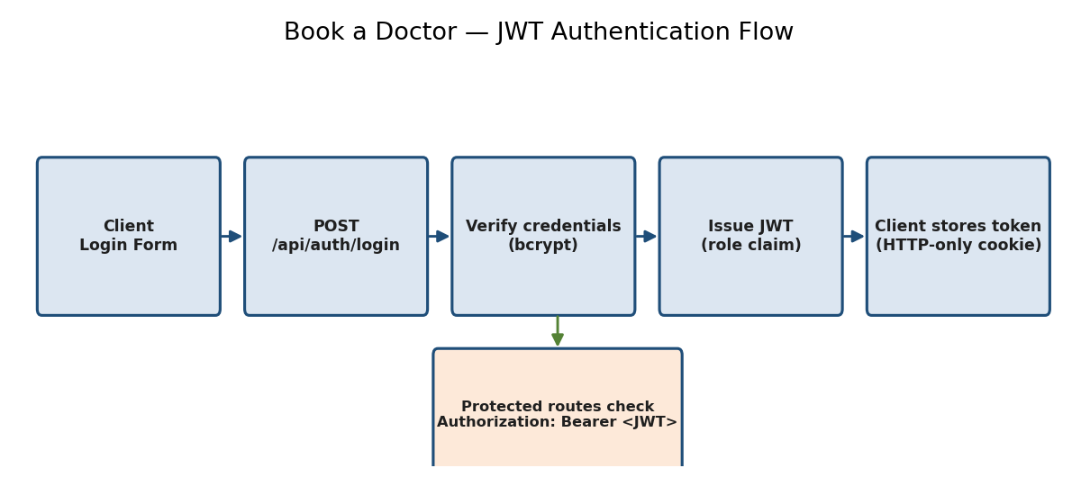
Fig. 4 — JWT-based authentication and route-protection flow
Role-Based Access Control (RBAC)
Role | Permissions
Patient | Book/reschedule/cancel own appointments, view own profile & payments
Doctor | View/manage own appointments, update own profile & availability
Admin | Full access: manage doctors, patients, appointments, and platform settings
Security Practices
- Passwords hashed with bcrypt before storage; plain-text passwords are never persisted or logged.
- JWTs are short-lived, with a refresh-token flow for extending sessions without re-entering credentials.
- All API input is validated server-side; MongoDB queries use parameterized Mongoose methods to avoid injection.
- HTTPS enforced in production; HTTP-only, Secure cookies used for token storage.
- Rate limiting applied to auth endpoints to reduce brute-force risk.

9. User Interface
Core UI flows: patient search & booking, doctor's appointment dashboard, and the admin panel for managing doctors, patients, and platform data.
Screens by Role
- Patient — Login/Register, Doctor Search & Filters, Doctor Profile, Booking & Payment, My Appointments.
- Doctor — Login, Appointment Dashboard, Availability Settings, Profile Editor.
- Admin — Login, Doctor Management, Patient Management, Platform Analytics, Notification Settings.
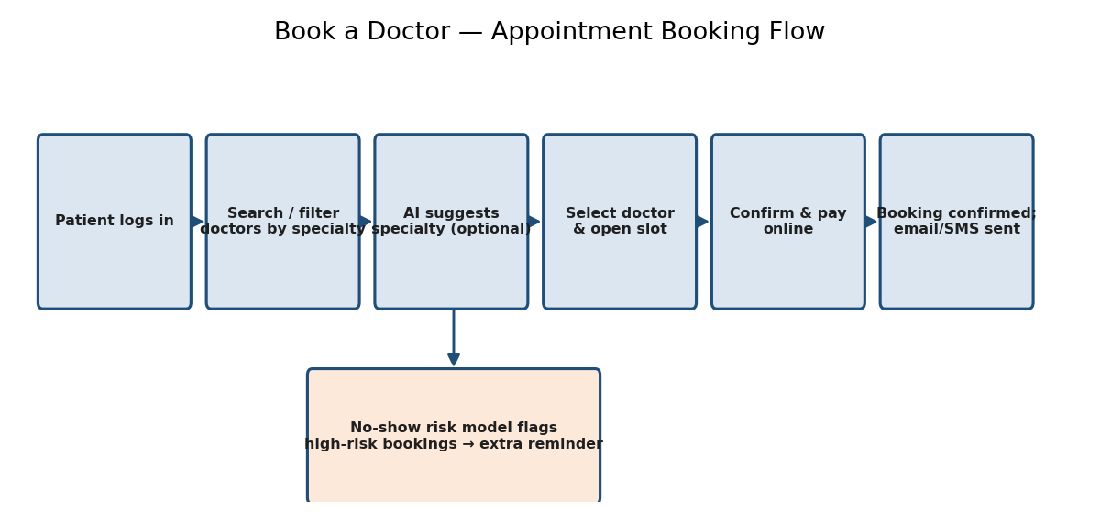
Fig. 5 — Appointment booking flow across patient, AI recommendation, and confirmation steps
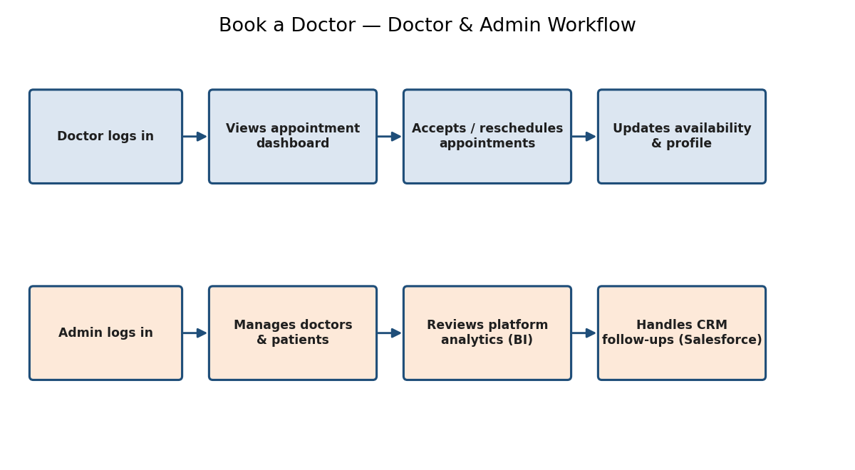
Fig. 6 — Doctor and Admin workflow
Note: Insert actual app screenshots here (login, search results, booking confirmation, doctor dashboard, admin panel) once available.

10. Testing
Testing strategy follows a standard pyramid: many fast unit tests, fewer integration tests, and a thin layer of manual UAT before release.
- Unit tests — controllers, services, and utility functions (Jest).
- Integration tests — API endpoints against a test database (Supertest).
- Manual UAT — full user flows on the staging environment, covering registration, search, booking, payments, and dashboards.
UAT Test Cases (Summary)
ID | Scenario | Expected Result | Result
TC-001 | Register with valid email & password | Account created; redirected to login | Pass
TC-002 | Cannot register with used email | Error: 'Email already registered' | Pass
TC-003 | Search doctors by specialty | List shows only matching specialty, sorted by availability | Pass
TC-004 | Book an available slot | Slot booked, marked unavailable, confirmation shown | Pass
TC-005 | Cannot double-book same slot | Second request blocked with 'Slot no longer available' | Pass
TC-006 | Doctor views upcoming appointments | List shown with patient name & time | Pass
TC-007 | Admin deactivates a doctor profile | Doctor hidden from search; record retained | Pass
TC-008 | Payment fails gracefully on declined card | Clear decline message; booking not confirmed | Fail
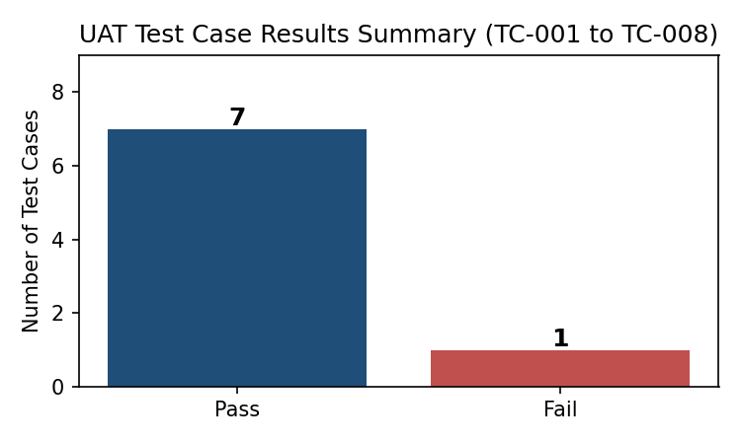
Fig. 7 — UAT result summary: 7 of 8 executed test cases passed

11. Screenshots or Demo
Supporting analytics and integration screenshots from the project's reporting and CRM layers:
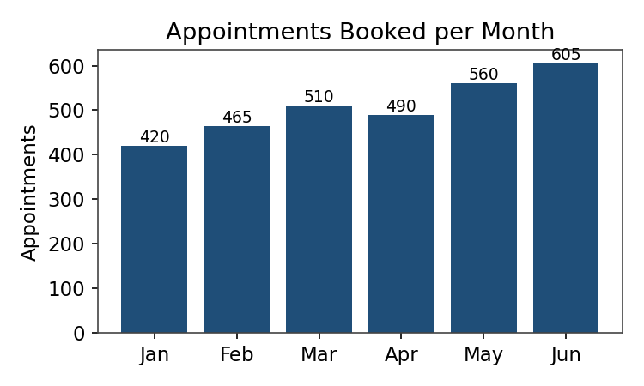  Power BI — Appointments Booked per Month | 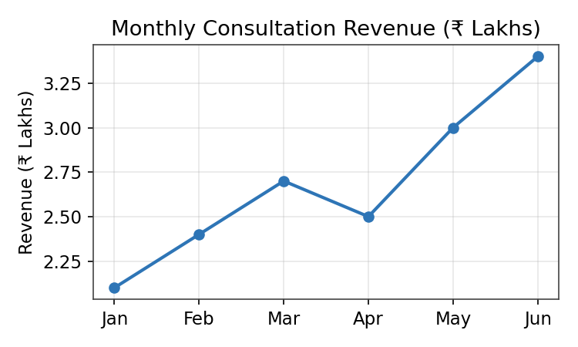  Tableau — Monthly Consultation Revenue
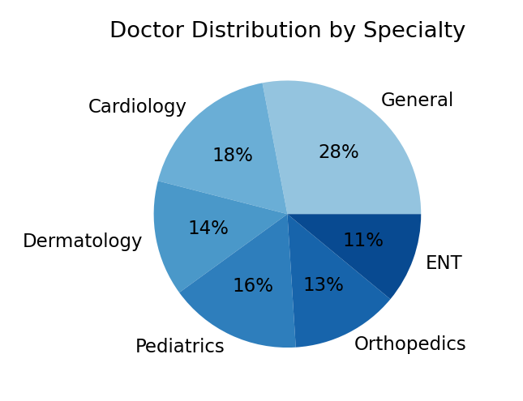  Power BI — Doctor Distribution by Specialty | 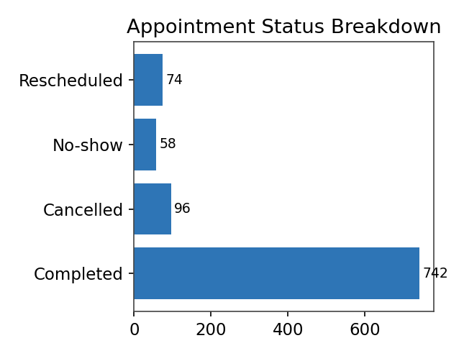  Tableau — Appointment Status Breakdown
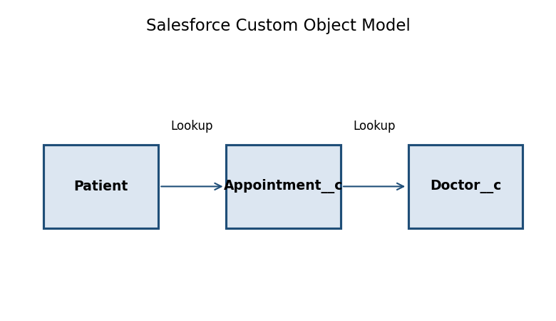  Salesforce — Custom Object Model | 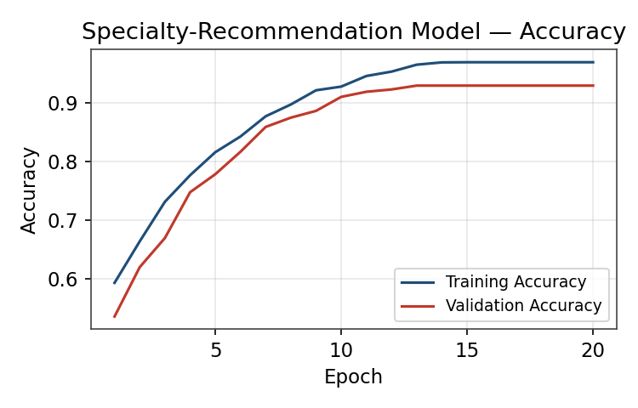  AI — Specialty Recommendation Model Accuracy
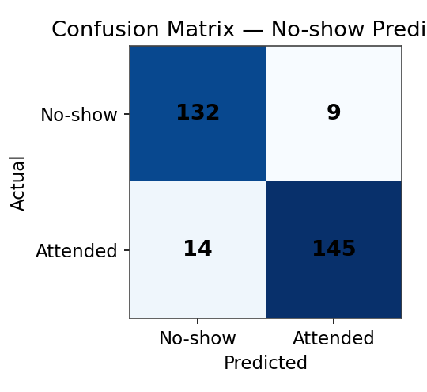  ML — No-show Prediction Confusion Matrix | 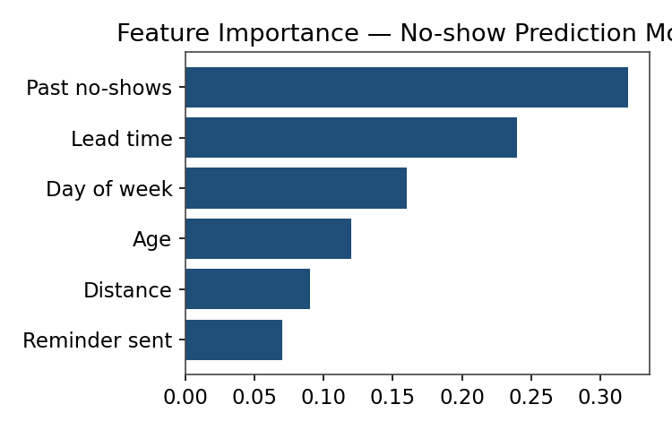  ML — No-show Model Feature Importance

12. Known Issues
Bug ID | Description | Severity | Status | Feedback
BG-001 | Decline-message wording on failed payment is unclear to users | Medium | Open | Use plain-language message: 'Payment declined by your bank — please try another card.'
BG-002 | Reschedule confirmation email delayed by ~5 seconds | Low | In Progress | Check the email queue/worker under load.

13. Future Enhancements
Phase | Planned Enhancement
Phase 1 | Video/tele-consultation support for remote appointments
Phase 1 | Multi-language support for the patient-facing UI
Phase 2 | Push notifications via a dedicated mobile app
Phase 2 | Expanded AI triage covering more specialties and multi-symptom input
Phase 3 | Wearable/health-tracker data integration for richer no-show and risk prediction

14. Appendix
Glossary
Term | Definition
MERN | MongoDB, Express.js, React.js, Node.js — the technology stack used in this project
JWT | JSON Web Token — a compact, signed token used for stateless authentication
RBAC | Role-Based Access Control — restricting actions based on a user's assigned role
UAT | User Acceptance Testing — manual testing performed by end users before release
No-show | A booked appointment where the patient does not attend and does not cancel in advance
DAX | Data Analysis Expressions — the formula language used in Power BI
References
- Separate UAT report: User_Acceptance_Testing_FSD_Book_a_Doctor.docx
- Model performance reports: Artificial_Intelligence_Book_a_Doctor.docx, Machine_Learning_Book_a_Doctor.docx
- Analytics/CRM reports: Power_BI_Book_a_Doctor.docx, Tableau_Book_a_Doctor.docx, Salesforce_Book_a_Doctor.docx

